Course Name: | Digital Signal & Image Processing | Semester: | VI
Date of Performance: | 11/02/26 | DIV/ Batch No: | A1
Student Name: | Aaryan Sharma | Roll No: | 16010123012

Title: Write a program to Compute linear and circular convolution of two discrete time signal sequences using Matlab.

Objective: To familiarize the beginner to MATLAB by introducing the basic features and commands of the program.
Expected Outcome of Experiment:

CO | Outcome
CO3 | To understand the concept of convolution and perform different convolution operations on the given input signals.

Books/ Journals/ Websites referred:
- http://www.mathworks.com/support/
- www.math.mtu.edu/~msgocken/intro/intro.html
- www.mccormick.northwestern.edu/docs/efirst/matlab.pdf
- A.Nagoor Kani “Digital Signal Processing”, 2nd Edition, TMH Education.

Pre Lab/ Prior Concepts:
Convolution
Discrete time convolution is a method of finding the response of a linear time invariant system. It is based on the concepts of linearity and time invariance and assumes that the system information is known in terms of its impulse response h[n].
Convolution is defined as
∞
Y[n] = Σ h[k]x [n-k] =h[n]*x[n] k=-∞
Convolution consists of folding, shifting, multiplication and summation operations.

Circular Convolution
Circular convolution between two length N sequences can be carried out as shown by the expression below:
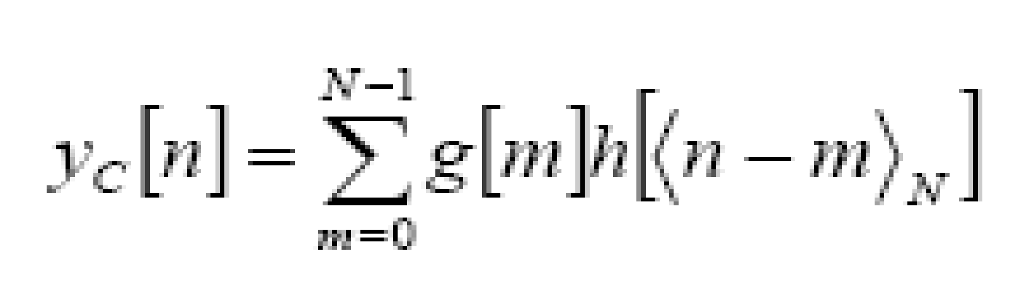
Since the above operation involves two length-N sequences it is referred to as the N-point circular convolution and denoted by:
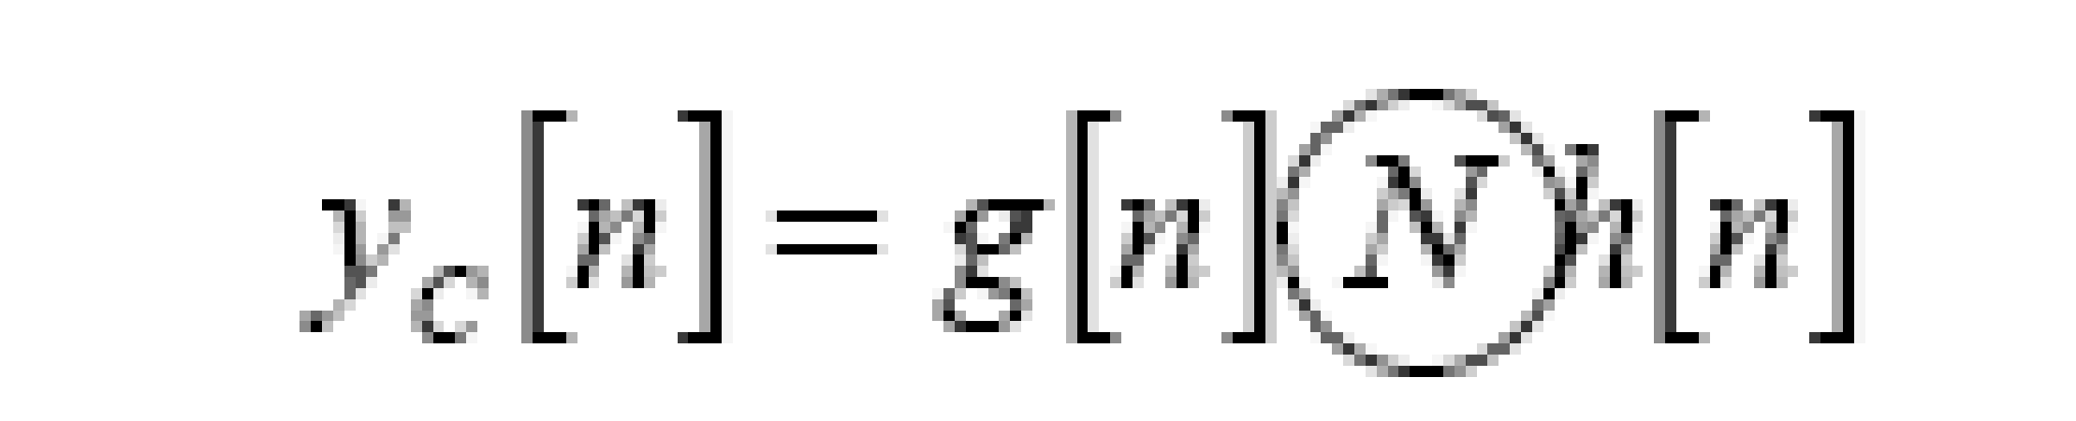
As in linear convolution circular convolution is commutative.
i.e.
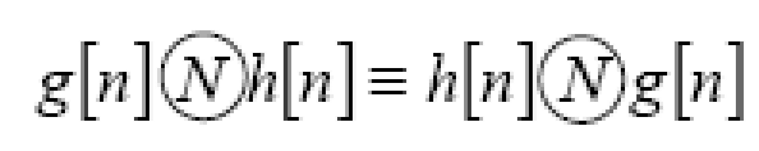
Example Of Linear Convolution:
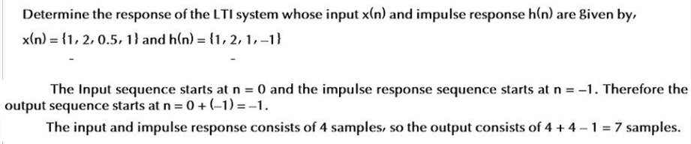Example Of Circular Convolution:
Implementation details along with screenshots:
Linear Convolution
clc;
clear;
close all;

x = [1 2 0.5 1]; % x(n), starts at n = 0
h = [1 2 1 -1]; % h(n), starts at n = -1

n_x = 0:length(x)-1; % 0,1,2,3
n_h = -1:length(h)-2; % -1,0,1,2

h_fold = fliplr(h); % reverse sequence
n_h_fold = -fliplr(n_h); % reverse index and change sign

y = conv(x, h);

n_y_start = n_x(1) + n_h(1); % 0 + (-1) = -1
n_y = n_y_start : n_y_start + length(y) - 1;

figure;
stem(n_x, x, 'filled');
title('Input Signal x(n)');
xlabel('n');
ylabel('Amplitude');
grid on;

figure;
stem(n_h, h, 'filled');
title('Impulse Response h(n)');
xlabel('n');
ylabel('Amplitude');
grid on;

figure;
stem(n_h_fold, h_fold, 'filled');
title('Folded Impulse Response h(-n)');
xlabel('n');
ylabel('Amplitude');
grid on;

figure;
stem(n_y, y, 'filled');
title('Output Signal y(n) = x(n) * h(n)');
xlabel('n');
ylabel('Amplitude');

grid on;
disp('Output y(n):');
disp(y);
disp('Output index n:');
disp(n_y);
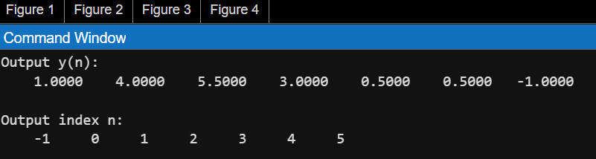
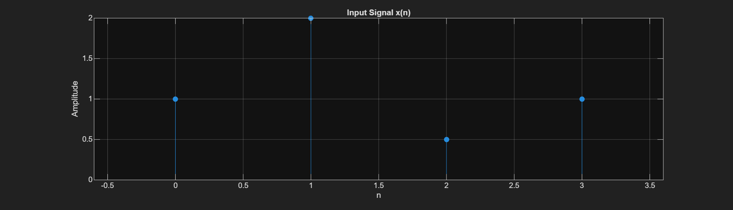
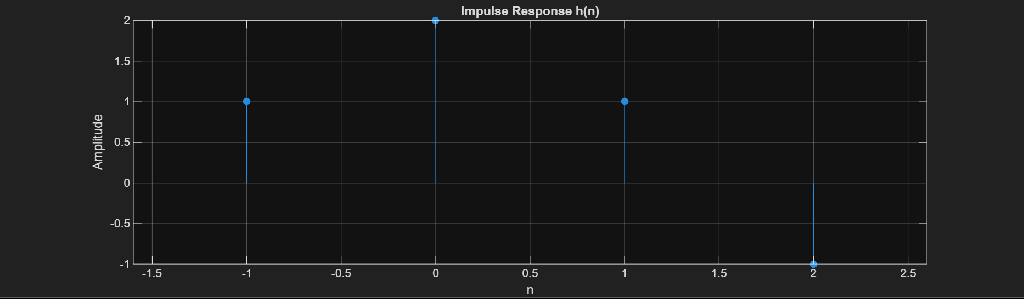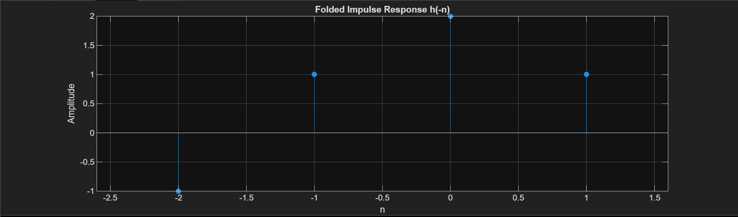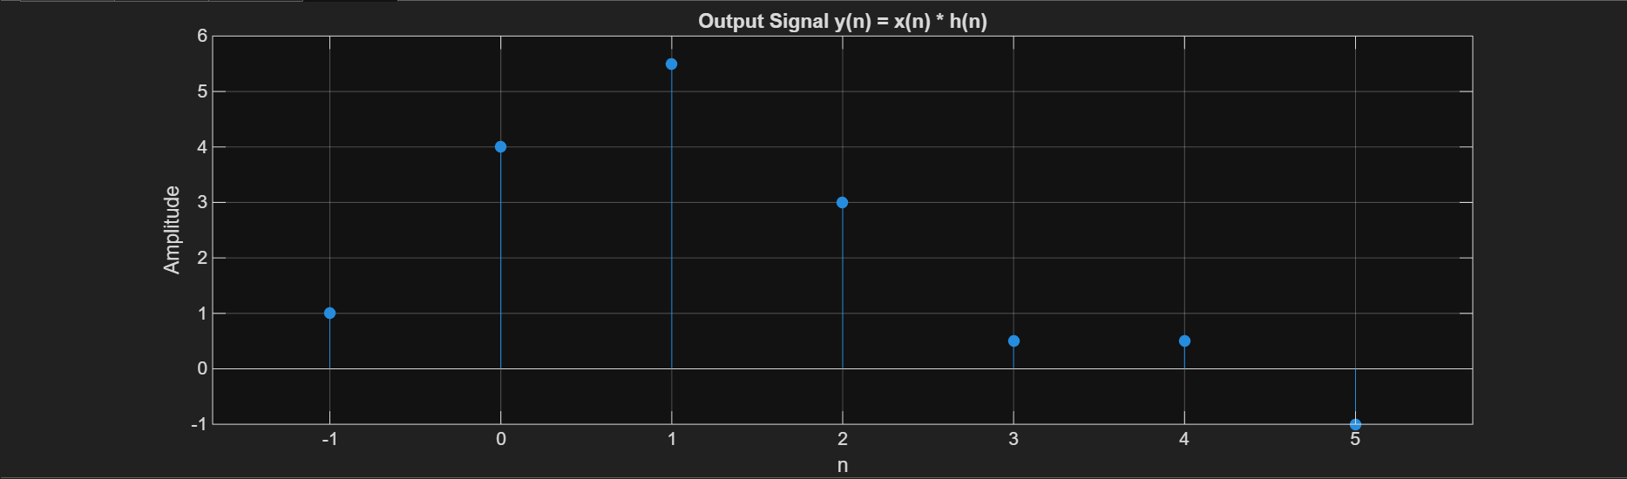
Circular Convolution
clc;
clear;
close all;
x1 = [2 1 2 -1]; % x1 sequence
x2 = [1 2 3 4]; % x2 sequence

N = length(x1);
n = 0:N-1;
y = cconv(x1, x2, N);

figure;
stem(n, x1, 'filled');
title('Sequence x_1(n)');
xlabel('n');
ylabel('Amplitude');
grid on;

figure;
stem(n, x2, 'filled');
title('Sequence x_2(n)');
xlabel('n');
ylabel('Amplitude');
grid on;

figure;
stem(n, y, 'filled');
title('Circular Convolution using cconv()');
xlabel('n');
ylabel('Amplitude');
grid on;

disp('Circular Convolution Output y(n):');
disp(y);
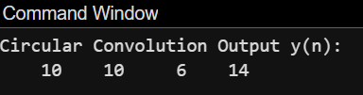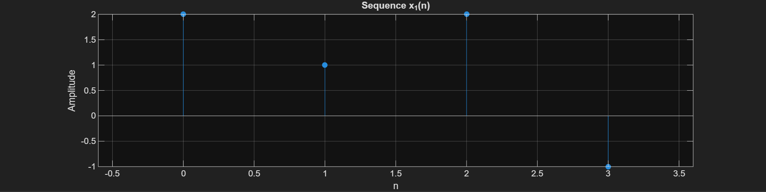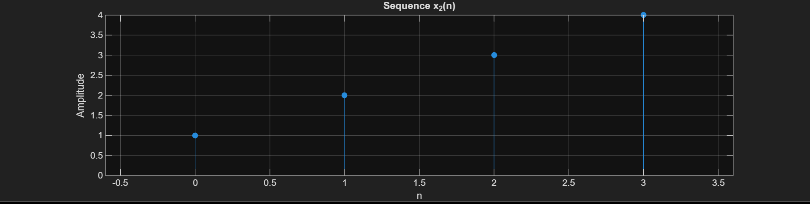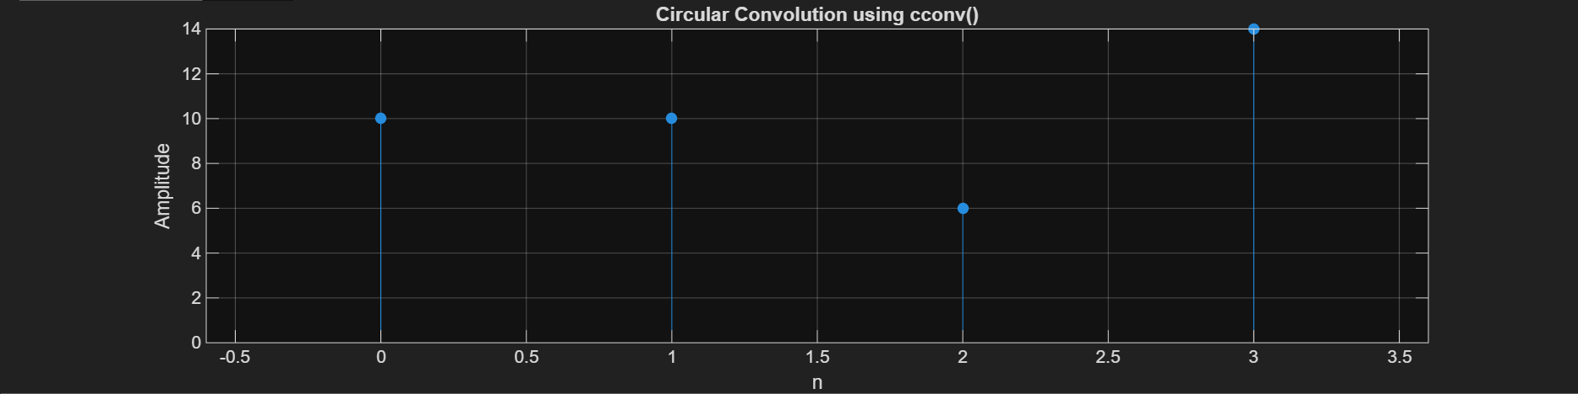
Conclusion:
In this experiment, we learned how to compute both linear and circular convolution of discrete-time signals using MATLAB. Linear convolution helped us understand how an LTI system produces its actual output, while circular convolution showed how signals behave when treated as periodic with a wrap-around effect. Using MATLAB functions like conv() and cconv() made the calculations easier and helped us clearly visualize the results.
Date: 11/02/26 Signature of faculty in-charge
Post Lab Descriptive Questions
  - Explain the role of convolution in signal processing.
Convolution is an important concept in signal processing because it explains how a system changes or responds to an input signal. In simple terms, if we know how a system reacts to a single impulse (its impulse response), convolution helps us determine how it will respond to any signal. It combines the input signal and the system’s response in a structured way to produce the final output.
- It allows us to find the output of Linear Time-Invariant (LTI) systems.
- It is widely used in filtering, such as removing noise from signals.
- It helps model practical systems like communication channels and audio effects.
- It connects time-domain and frequency-domain analysis, making signal processing more efficient.
  - Explain the difference between linear and circular convolution?
Linear convolution is used to determine the complete response of a Linear Time Invariant system when an input signal is applied. It does not assume periodicity of the signals. If two sequences of lengths L₁ and L₂ are convolved linearly, the output sequence has a length of L₁ + L₂ − 1. Linear convolution represents the actual physical response of practical systems such as filters, communication channels, and audio systems. Circular convolution, on the other hand, assumes that the given sequences are periodic with period N. During computation, the indices wrap around using modulo-N operation. The output sequence always has length N. Circular convolution is mainly used in frequency-domain analysis and in applications involving Discrete Fourier Transform and Fast Fourier Transform. The key difference lies in the boundary conditions. Linear convolution does not involve wrapping of samples, whereas circular convolution causes overlapping of samples due to periodic extension. Circular convolution becomes equivalent to linear convolution when both sequences are zero-padded to a length equal to or greater than L₁ + L₂ − 1. Thus, linear convolution represents true system behavior, while circular convolution is a mathematical tool used in digital signal processing for efficient computation.
  - Explain with the help of an example the steps required to transform linear convolution with circular convolution and vice-versa.
1. Linear Convolution to Circular Convolution
Linear convolution of two finite-length sequences can be obtained using circular convolution by zero-padding both sequences to a length
N≥L+M−1
where:
- L = length of x(n)
- M = length of h(n)

Example
Let
x(n)={1,2,3}
h(n)={1,1,1}
Here,
L=3, M=3Required length:
N=L+M−1=3+3−1=5
Step 1: Zero Padding
Pad both sequences to length 5:
x(n)={1,2,3,0,0} h(n)={1,1,1,0,0}

Step 2: Perform 5-point Circular Convolution
Compute:
y(n)=x(n)⊛h(n)
Result:
y(n)={1,3,6,5,3}

Step 3: Observe Result
This is exactly the linear convolution result.
Hence,
Linear Convolution = Circular Convolution (with proper zero padding)

Circular Convolution to Linear Convolution
Circular convolution causes time-domain aliasing when the length N is smaller than L+M−1.
To recover linear convolution:
- Either increase N
- Or use overlap-save / overlap-add method
Example
x(n)={1,2,3} h(n)={1,1,1}
Now perform 3-point circular convolution (no zero padding).
Result:
y(n)={6,6,6}
This is incorrect because linear convolution was:
{1,3,6,5,3}
The tail values are wrapped around and added to the beginning.
Step 1: Choose
N≥L+M−1
Step 2: Zero pad both sequences
Step 3: Perform N-point circular convolution
Then:
Circular Convolution=Linear Convolution

